Lab: Managing Hadoop Services

|  |  |
| --- | --- |
| **Objective:** | To learn how to start and stop the various HDP, rolling restart bulk-host operations, service and component restart. |
| **Successful Outcome:** | You learn various ways to manage HDP service. |
| **Before You Begin:** | Your cluster should be up and running. Go to the Ambari Dashboard [localhost]:8080 |

You can stop/start/restart service(s) at different levels

* Some OR all the services running in a cluster (e.g. stop HDFS)
* Some OR all the services running on a specific host (e.g. stop HDFS services on one host only)
* An individual component of a service (e.g. restart NameNode only)

1. Stop the HDFS service (Cluster level operation).

*NOTE: your Dashboard may have differing buttons and results.*

* 1. Go to your Ambari Dashboard and click on **Services** tab:



* 1. By default ‘HDFS’ is preselected. Click on ‘Stop’ option. Select ‘Confirm Stop’ in the confirmation popup and see the progress of stopping progress:

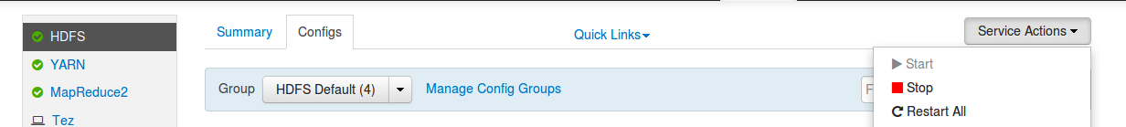

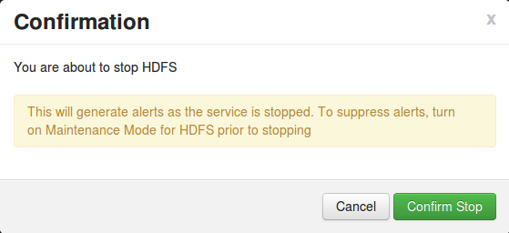

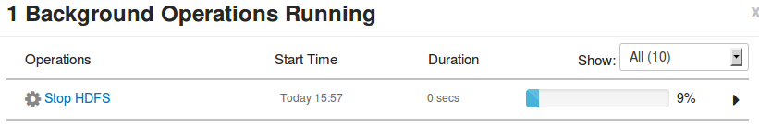

* 1. Press ‘OK’ once it is done. Now you can see in the dashboard that HDFS service is completely stopped (It takes couple of mins to get status update):

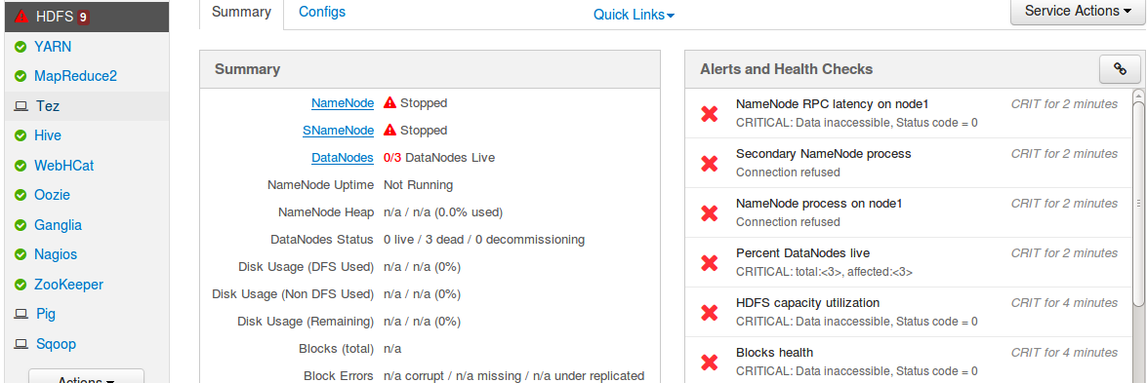

1. Start HDFS services for ‘hadoop-master’ only (Component level operation):
   1. Click on **Hosts** tab and click on ‘hadoop-master’:

Macintosh HD:Users:manish:Library:Application Support:com.yellowmug.SnapNDrag:9f20a9f60:screenshot_19.png

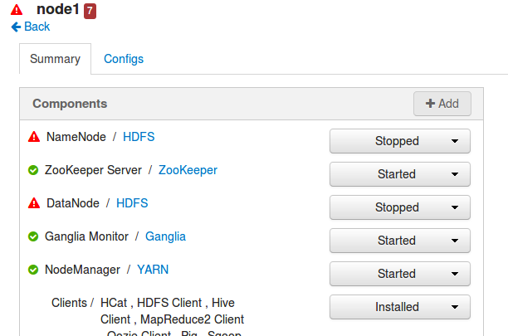

* 1. Click on **Hosts** tab and click on ‘hadoop-master’:



* 1. Start NameNode and DataNode components from the drop down.
  2. Now go to node3 and start the DataNode.

1. Start all stopped services for node2 (Host-level operation)
   1. Go to node2 and under ‘Host Action’ click ‘Start All Components’. It will start all stopped services on the host:

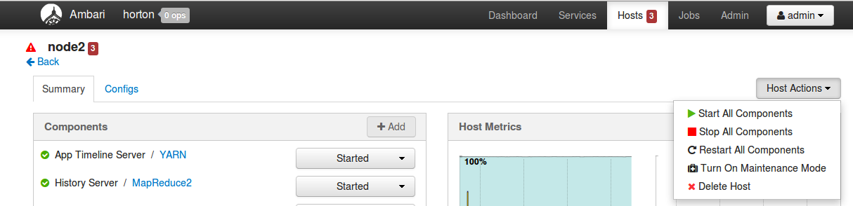

1. Manage services from command line using **Ambari Command Line API**.
   1. Login to **hadoop-master** using ‘Terminal’ application and review following script:

# cat ~/scripts/restartYARN.sh

It has 2 commands, one to stop YARN service and other to start YARN service.

* 1. Run the script to restart YARN service on your cluster:

# ~/scripts/restartYARN.sh

* 1. Wait for the script to execute and YARN service to restart. You can track the progress by click here:

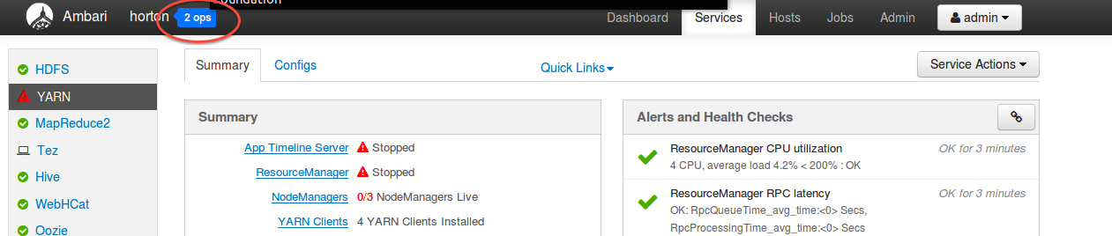

1. Take a backup of your VM.
   1. From the Services page, click the Stop All button. Click the OK button to confirm.
   2. Run the following script to shutdown all Ambari services on your cluster:

# ~/scripts/stop\_ambari.sh

* 1. Go to VMWare Player/Fusion Menu and shutdown the VM.
  2. Copy the existing VM folder from current location to a new location.
  3. Once you are done with backup, go to VMWare Player/Fusion Menu and start the VM again.

**NOTE**: It is important to take a backup of the VM now so that you do not need to start from beginning in case of a fatal error.

1. Start Ambari services
   1. Login to hadoop-master again
   2. Run the following script to start all Ambari services on your cluster:

# ~/scripts/start\_ambari.sh

1. Start the HDP Services from Ambari UI
   1. Go To Ambari UI using Firefox browser
   2. From the Services page, click the Start All button. Click the OK button to confirm.
   3. Wait for the services to start, which can take 10-15 minutes. If you click the small arrow to the right of “Start All Services”, you can view the progress on each node:

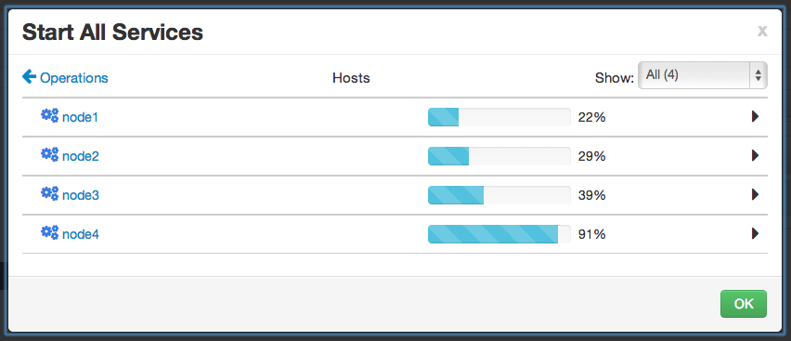

* 1. Once all the services are started, click the OK button to close the progress dialog.
  2. Verify on the Services page of Ambari that all the HDP services in your cluster are up and running.